**Capstone Project - The Battle of Neighbourhoods Week 2**

# Requirements:

A full report consisting of all of the following components:

1. Introduction where you discuss the business problem and who would be interested in this project.
2. Data where you describe the data that will be used to solve the problem and the source of the data.
3. Methodology section which represents the main component of the report where you discuss and describe any exploratory data analysis that you did, any inferential statistical testing that you performed, if any, and what machine learnings were used and why.
4. Results section where you discuss the results.
5. Discussion section where you discuss any observations you noted and any recommendations you can make based on the results.
6. Conclusion section where you conclude the report.

# Problem definition and data:

The problem to be solved consists of the opening of a gym business in the city of Valencia, Spain. More precisely, I look for a good location nearby the city center of the city.

People usually go to the closest gym of their neighbourhoods so I will try to find a place with low density of gyms.

In reference to the data, I am going to use Foursquare location data to know:

1. Where are the gyms located
2. Which is the valuation the clients give to them

This will allow me to find the perfect place to my gym.

# Methodology followed

1. Import the necessary libraries to solve the problem (requests, pandas, numpy, etc.)
2. Use Foursquare API and credentials
3. Define the initial location of our potential business area
4. Define the radius
5. Send the Get request and examine the results
6. Transform the data into pandas and clean the dataset
7. Visualize the location of our potential competitors in the selected aea
8. Define an area to establish our gym business

# Conclusions

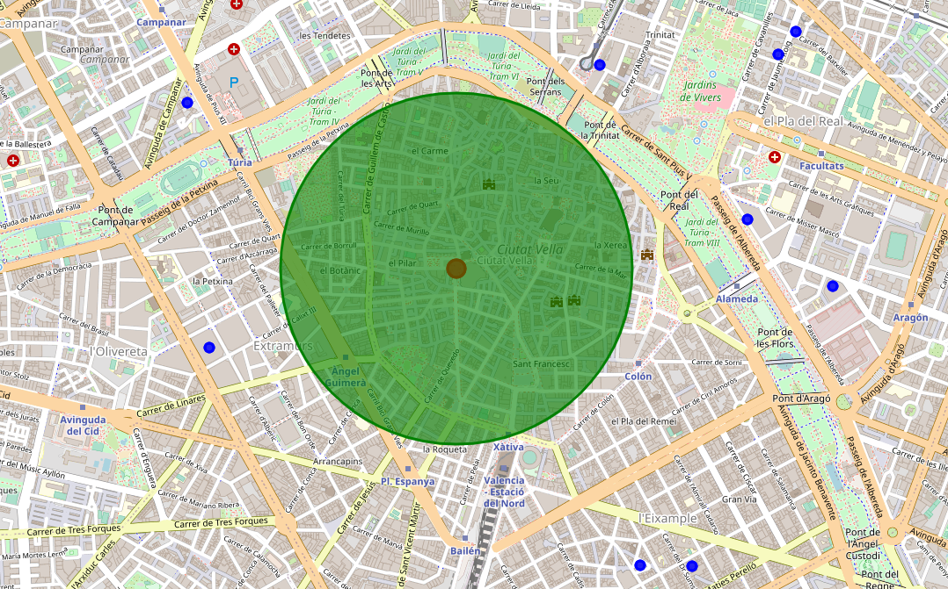

The city center of Valencia is a good area to establish a gym business. There is a lack of gyms nearby the "Mercado Central" so that clearly exists a business opportunity. Now the problem will continue by exploring venues with following characteristics:

* Enough venue size (squared meters)
* Good price for the venue in euros per square meter
* Good accessibility for potential clients
* Enough parking places in the surroundings
* Etc.